Big Data Final Project

Brazilian E-Commerce Public Dataset

by Olist

Overview:
In this report we made an analysis on Brazilian e-commerce public data set and we trained a multi-nominal logistic regression to predict category of new product
Introduction:
With the massive amount of data and the available advanced technologies, that can serve us to analysis and get useful information from the available huge data, using technologies like spark, Hadoop MongoDB and others, to process big data most of time it gives very high speed, and same accuracy.
Using distributed systems for analyzing e-commerce data has very useful effect to improve companies’ decisions, and make pure view to demands and supply to balance them, and enables companies to personalize the user preferences and needs.
At this report we will analyses Brazilian e-commerce public dataset, and we will build a model to predict to category of the product, using spark stand alone and fully-distributed modes.
Brazilian E-commerce Dataset:
This dataset provided by Kaggle consists of nine tables, but I used only seven tables include information about customers, orders, order items, products, order reviews, sellers, order payment way, the fields for each table as follow:

  Olist Customers Dataset
  Customer Id
  Customer Unique Id
  Customer Zip code Prefix
  Customer City
  Customer State
  Olist Orders Dataset
  Order Id
  Customer Id
  Order State
  Order Purchase Timestamp
  Order Approved At
  Order Delivered Carrier Date
  Order Delivered Customer Date
  Order Estimated Delivery Date
  Olist Order Items Dataset
  Order Id
  Order Item Id
  Product Id
  Seller Id
  Shipping Limit Date
  Price
  Freight Value
  Olist Products Dataset
  Product Id
  Product Category Name
  Product Name Lenght
  Product Description Lenght
  Product Photos Qty
  Product Weight g
  Product Length cm
  Product Height cm
  Product Width cm
  Olist Order Reviews Dataset
  Review Id
  Order Id
  Review Score
  Review Comment Title
  Review Comment Message
  Review Creation Date
  Review Answer Timestamp
  Olist order Payments Dataset
  Order Id
  Payment Sequential
  Payment Type
  Payment Installments
  Payment Value
Olist sellers Dataset
Seller Id
Seller Zip code Prefix
Seller City
Seller State

The schema presents the relationship between these tables:
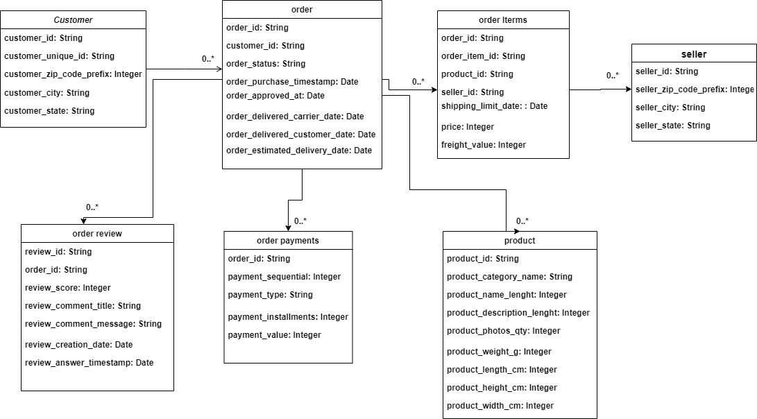
Data Analysis:
analysis answered the following questions:
*How many customers and sellers in each city and which cities have highest number of customers and sellers?
Using customers table to know number of customers from each city, and by using sellers table to get number of seller in each city and by get the intersection between them we can find cities with highest online economic activity
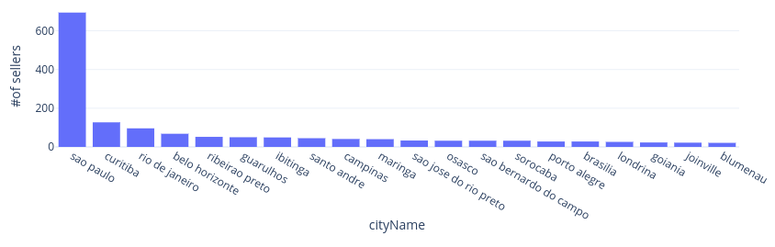
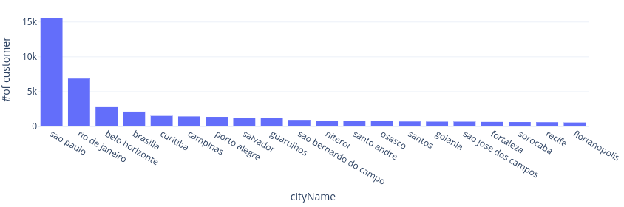
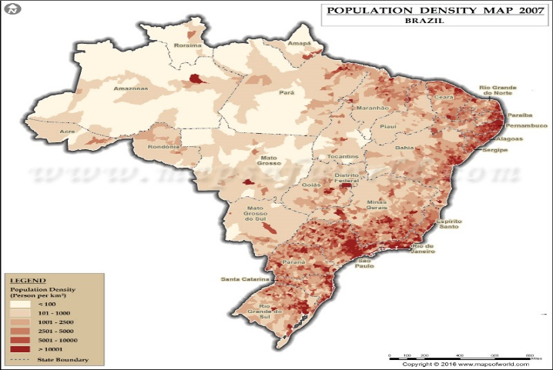
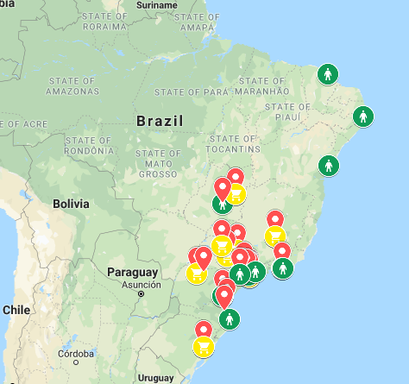
If we look at brazil map we can notice these cities also have highest population “https://www.google.com/maps/@-22.7105902,-63.865403,4z/data=!4m2!6m1!1s1j-jnebLxrOtJZRidx9S2s1RtVsKXFmPA?hl=en”
*How many order for each category from each city?!
Joining customers, orders, order Items and products tables to count number of products of category ordered from each city, if we select one category like cama_mesa_banho we can see the cities that ordered highest amount of products from that category
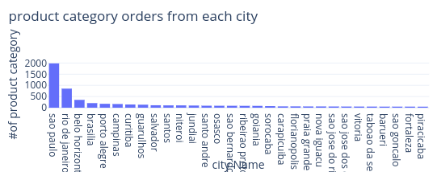
And we can know the most required categories for each city, if we considered sao paulo city
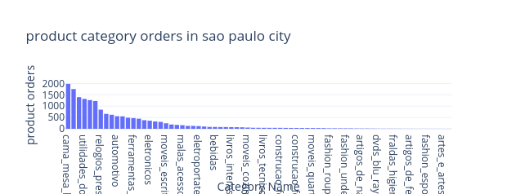

*which category does not have seller in sao Paulo and how many sellers for each category??!
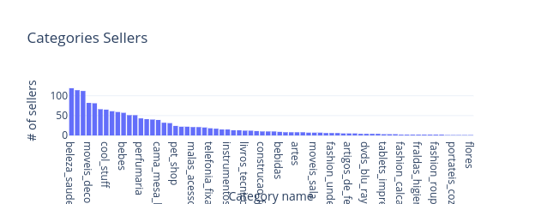
By using result of joining from previous question with sellers table to count number of seller for each category.

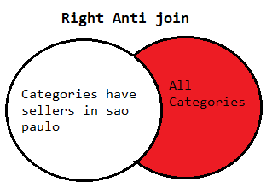
Then to know which category doesn’t have seller in sao Paulo city, we take the previous result and make anti right joining with the existing categories, then we get four categories doesn’t have sellers in the city these categories are: pcs, la_cuisine, seguros_e_sevicos and cds_dvds_musicias

*Which payment way does the customers prefer?!?
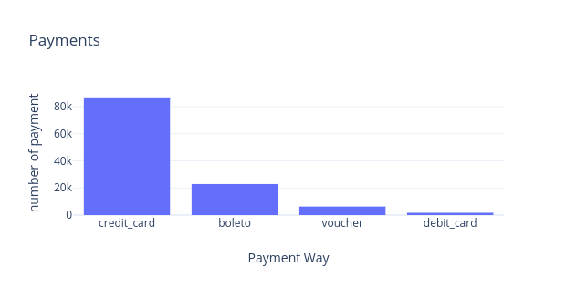
By knowing number of payment for each payment way we can get the preferred payment way by customers

*How many reviews for each category with each review score?!?
Depending on the order reviews, we get the order items to know each item category and show which category takes highest scores, if we look at the figure “this figure only for first 30 categories that have review score 5” bellow we can see that the orders which contains products o beleza_saude get highest 5 review score.
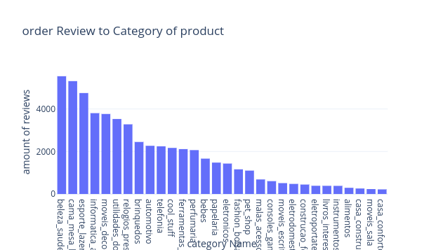

Create prediction model:
Create a model that can be able to predict the category of the product depending on its attributes.
Multinomial Logistic Regression Model:
Multiclass classification includes logistic regression and softmax activation function to classify multiple classes, the model gives matrix of (KxJ) where K number of classes and j number of features.
Prepare data for training:
From products table select first 5 categories that have highest number of samples and their samples number very close to each other to make balance between them.
As the column data types are String and we need one feature vector and label to be the input for the model we made some transformation to convert them to vector.
- Features vector: index each categorical column(dtype: string) using StringInexer , then converts the indexed categories into oneHotEndcoded variables , actually it is not nesseccary to use but using it will increase the accuracy of the model, the resulting output has the binary vectors,the reulting output has binary vectors appended to the end of each row , next we used vectorAssembler to combine all feature column into single vector column this vector will be the input of Multinomial logistic regression.
- Label: we used the StringIndexer again to encode our labels to label indices.
- Divide the dataset into train and test datasets 0.9 for training,0.1 for testing
Pipeline:
Because we want to make chain of operations on our data, use the pipeline will be very helpful to apply the above steps within the pipeline workflow, each stage will be adding to stages array to be an input to the pipelines. The pipeline prepares that data set to be input to the model by prepare the features and label as explained above.
Training the model:
After training different parameters, best parameters are maxIter=60, regParam=0.1
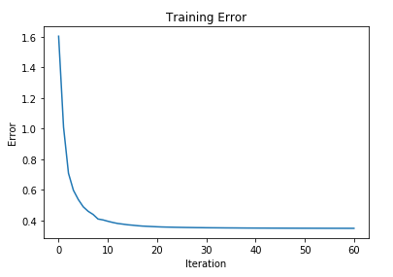
Training the model by fitting data frame result of pipeline in addition to the original data frame with the best parameters.
From the history of training we can see how the error decreases as figure:

Evaluation the model:
Using training summary to evaluate each class during training using different evaluation critters the evaluation as follow:
Evaluation criteria  Label | cama_mesa_banho | esporte_lazer | moveis_decoracao | Beleza  saude | Utilidades_  domesticas
Precision | 0.7695 | 0.7338 | 0.8011 | 0.8052 | 0.7437
Recall | 0.8909 | 0.7464 | 0. 7553 | 0. 7997 | 0. 6289
F-measure | 0. 8257 | 0. 7401 | 0. 8025 | 0.8940 | 0.6815

The evaluation the model during training and testing:

Evaluation criteria | Training | Testing
Accuracy | 0.77026 | 0.5202
Precision | 0.7701 | 0.5202
Recall | 0.7702 | 0.5202
F-measure | 0.76817 | 0.5202

If we compare training with testing result, we know that there is over fitting but changing
Regularization parameter doesn’t solve the problem in such cases we need more data for training but this unfortunately unavailable.

Compare Standalone mode vs fully-connected mode:

mode | Slave number | Slave Config | Running Time | Instance type
Fully-distributed | Two | 4vCore 16 GB memory, EBS only storage  EBS storage:64 GB | 87.208 second | M5.xlarge
Fully-distributed | Two | 4vCore 8 GB memory, EBS only storage  EBS storage:32 GB | 172.120 second | M4.large
Standalone | -- | Core i7 RAM 16GB  64-bit OS | 323.37 second | ---

Conclusion:
Analyze big data gives very useful information about the demand and supply of the online
market and create a model that be able to classify the product will increase speed of storing and
classifying new product easily but our model does not give good classification because of the
overfitting which we can solve it using more data.

Dataset source “ https://www.kaggle.com/olistbr/brazilian-ecommerce#olist_products_dataset.csv”

